

**Special School Outreach Support (SSOS) is working with Birmingham City Council to build**

**capacity for the support of young people with SEND across the city.**

**What is Special School Outreach Support (SSOS)?**

* Birmingham special schools are providing their expert staff to offer additional support to other educational settings.
* SSOS is a **free** service to Birmingham schools which has been funded by Birmingham City Council.

What will Special School Outreach Support (SSOS) provide?

SSOS providers work collaboratively with education staff to support the learning goals of pupils with special educational needs and disabilities.

SSOS work alongside existing BCC Inclusion Support Teams and provide additional capacity to their current offers. Your requests for support should be discussed and agreed with BCC teams at your multi-agency planning meetings.

The support offered is split into 3 levels; Level 1: Staff support, Level 2: Small group and Level 3: Individual

The support is individualised and tailored to each school request but can include the following:

* Demonstrating teaching strategies alongside education staff in school.
* Providing training for whole school staff or smaller groups of staff.
* Working with a small group of children or an individual child to achieve their learning goals.

# SSOS Evaluations

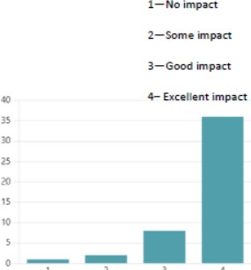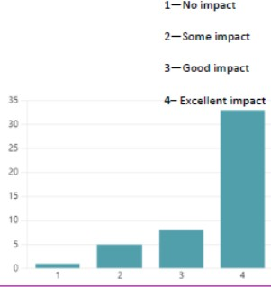

Overall effectiveness of support

Average score:

**3.55 / 4**

Teaching and learning strategies

Average score:

**3.68 / 4**

“This support has been really beneficial. It is not like any other support we have had over the years. Her knowledge and skills were evident and she was very supportive and approachable. We found that it was effective seeing it for ourselves in action and understanding how to use the aids correctly.”

“She was fantastic. Seeing her work in our setting, with our children modelling how she would lead a session/activity. Our staff now use her model as the template of the provision provided.”

“Empowering staff to realise the impact they are having by

supporting children with complex needs.”

“Mum is extremely happy that student has a better routine an is accessing more activities to meet his outcomes. It has helped to create a more consistency for school/home. “

“Modelling of PECs and attention autism. Being able to see this in practice when we visited the Special School has given staff more confidence.”

“Unlocking the specialist expertise from Birmingham City Special schools to support children and young people with SEND”

SSOS process for **receiver school **

* Raise request at your **multi-agency planning meetings**

to gain verbal consent from BCC agencies

* Complete a ‘new request for support’ form, found at [www.ssosbham.org.uk](http://www.ssosbham.org.uk/) for each individual student or group of students in the same year

Support request and BCC approval

Triage of cases

SSOS contact named BCC staff to gain formal BCC approval and yourself for Parental/carer consent form completion

Once documents are received, you will be assigned to a Special School who will make contact with you directly

Important documents / intent

Initial meeting is scheduled with the provider school and a SLA (service level agreement) will be completed to specify the expectations, desired outcomes and support that will be offered. **This must take place within 14 days of allocation.**

* Support is delivered **weekly** an agreed times (Maximum number of sessions: Level 1 – 6 sessions; Level 2 – 8 sessions; Level 3 – 10 sessions)
* Receiver school to implement strategies in their setting and disseminate information to other staff as necessary to build capacity

Delivery / implementation of specialist support

Evaluation/impact

Complete evaluation form sent by Provider school within **7 days**