

**We Went to Parliament!**

On Monday 28th November 2022, The RISE (Respect, Inclusion, Support and Equity) Youth

Forum and The YES (Youth Empowerment Squad) joined together to visit the House of Parliament in London.

London here we come!

Preparation for the visit started months before, with members of the groups expressing an interest in the trip, then signing up to attend. Several meetings took place to pre tutor us, so we knew exactly what to expect.

Keshia and Sarah also let us ask as many questions as we wanted about the trip.

“I am so excited for our trip to Parliament!”

“How do you address an MP or Lord?”

“What type of clothes should I wear?”

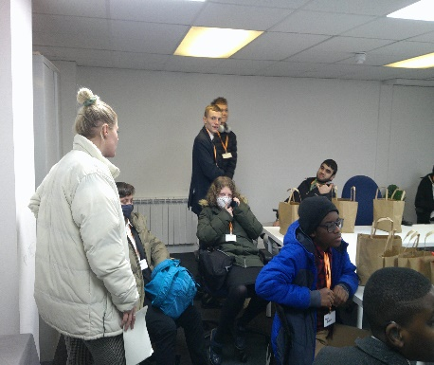

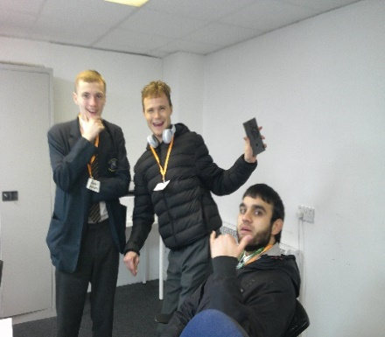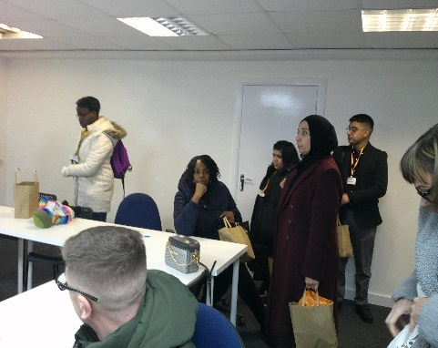

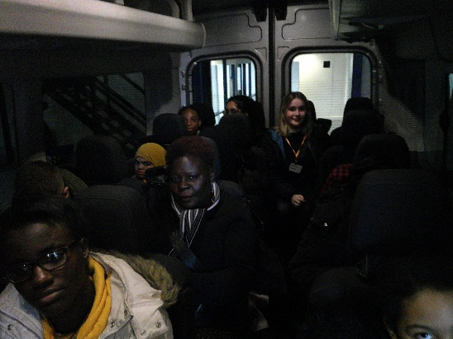Departure time was 8am! All the Young People were provided with a breakfast bag with a handful of healthy snacks inside.

At this point our adventure begun!

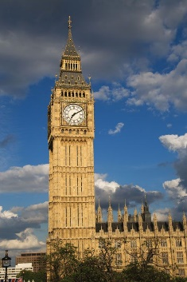

As we entered London, we started to see a few sights which many of us had only seen on TV.

Georgia described this as “incredible”.

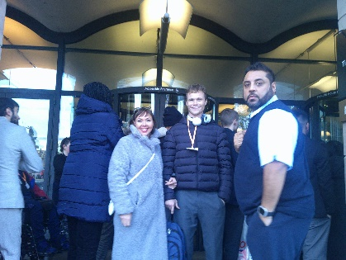We saw many landmarks, such as Big Ben, London Bridge, and the London Eye.

They were so much bigger in real life than on the T.V!

Once in London we were met by heaps of traffic, this did not stop our joy we sang songs and took many selfies until we arrived at Parliament.

We then headed into Portcullis House, this building is next to Parliament, we went through airport style security and some of us we even had to take off our shoes and belts.

Once in Portcullis House we were given a private meeting room where we then had lunch.

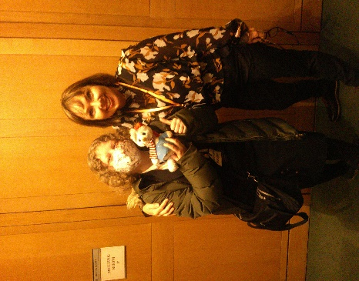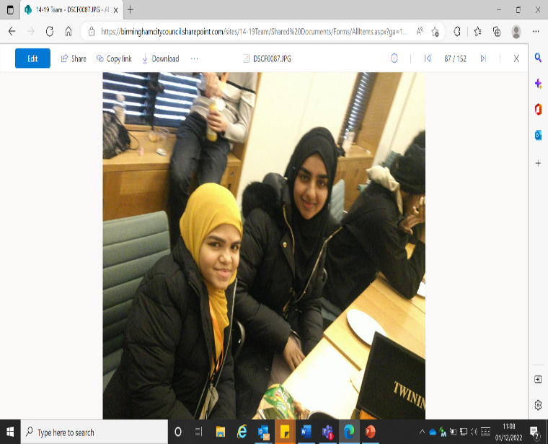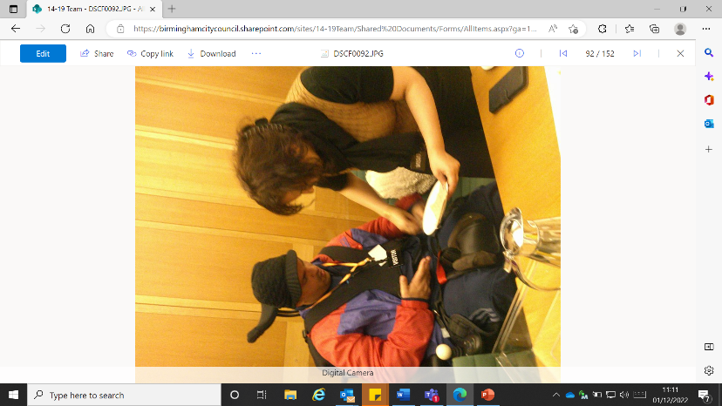We had to eat fast as the tour was about to begin.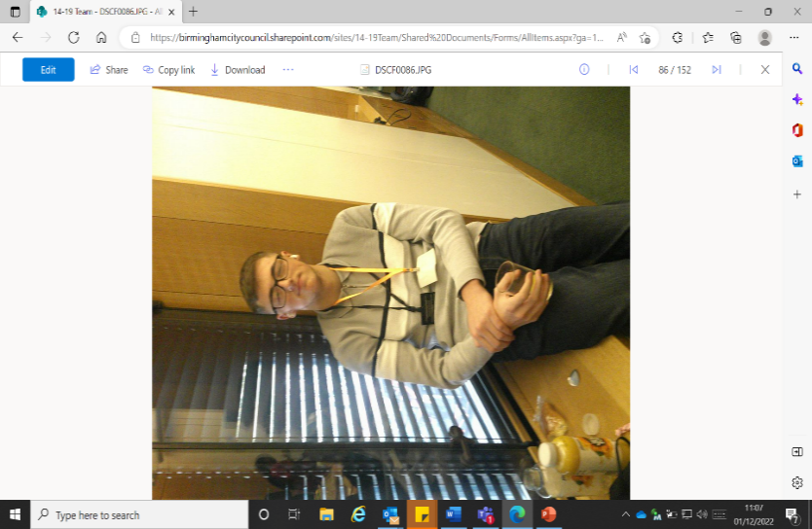

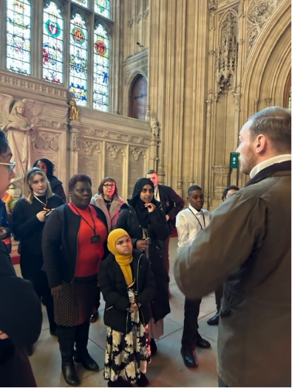Once we reached the education centre, we were greeted by two parliamentary tour guides Chris and Will. They were great, they understood all our needs and told us what we would be doing. Unfortunately, no pictures were allowed to be taken on our tour as this is against the rules. We asked many questions and listened to information about the building itself, we were in awe of the historic building.

Harrison described this as spectacular.

Kymarni stated “Pinch me! Am I dreaming?”

Later, we were privileged enough to be seated in the viewing chambers of the Houses of Parliament, at this time MPs were asking the Secretary of State for Education questions. We were then able to watch Dr Luke Evans MP for Bosworth ask

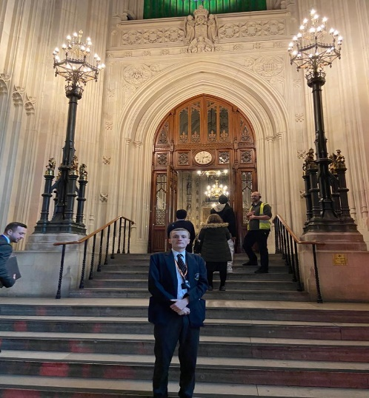“What steps her department is taking to increase the number of school places for pupils with (a) special needs and (b) disabilities.

Grahame Morris MP of Easington asked

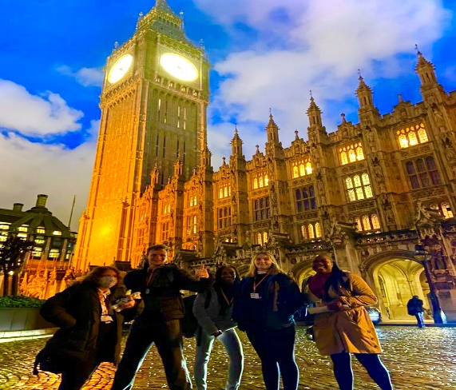“What support the Government is providing to help (a) schools and (B) parents with the cost of living.

Marco Longhi MP for Dudley North asked

“What steps her department is taking to support school pupils with their education recovery.”

We listened very carefully for the responses as later in the day we had a Q and A session with Birmingham Erdington’s Paulette Hamilton MP.

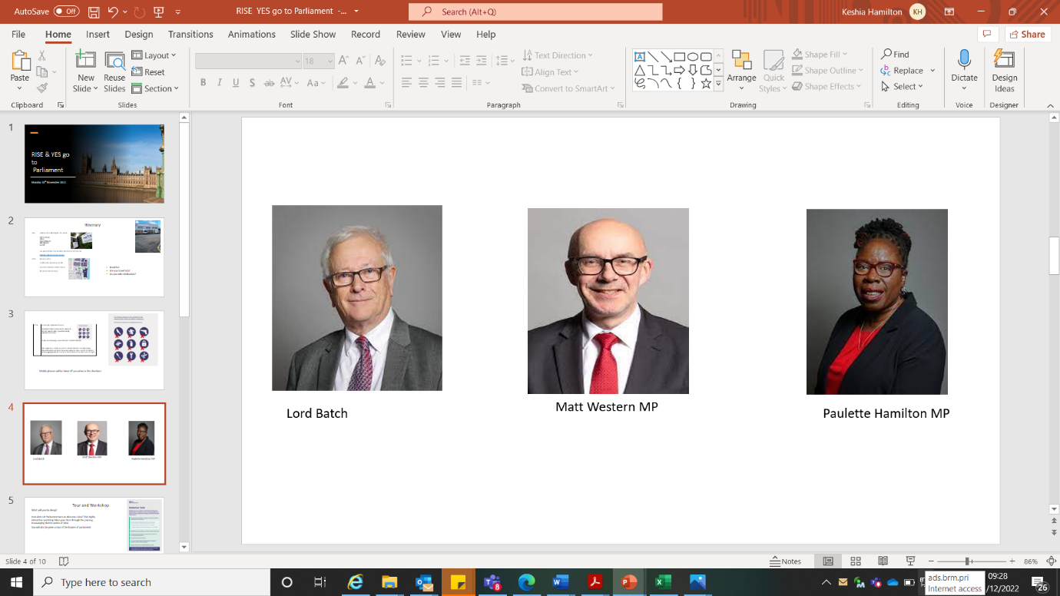Once we left the chambers, we headed back over to the education centre where we had a workshop on Law and Debating, it was here where we had found out how laws were made. Mason stated, “How interesting, I did not realise this.”

Halfway into the workshop Paulette Hamilton MP and her team came into the room, many of us were very excited and honoured as we have never met an MP before.

Paulette Hamilton MP started off by telling us her journey into Politics, she spoke about being a Councillor for 18 years and being a Cabinet Member for Adult Social Care and Public Health right here in Birmingham. She gave us a lot of interesting information which the whole group really took on broad.

RISE and YES were then given the chance to ask the MP questions. They had asked

“How do you plan to address the cost-of-living crisis?”

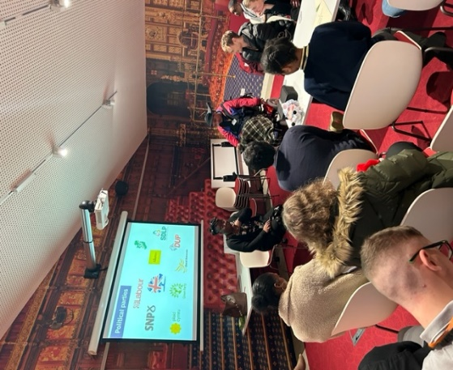“What advice would you give to me if I would like to have a law change?”

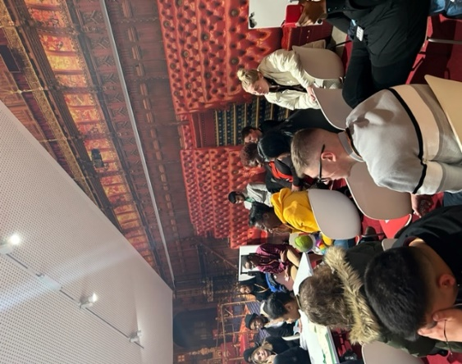

After this we all took photos with Paulette Hamilton MP.

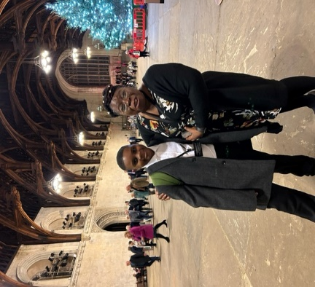Marium stated, “It was a perfectly well ending to the day as the young people were able to ask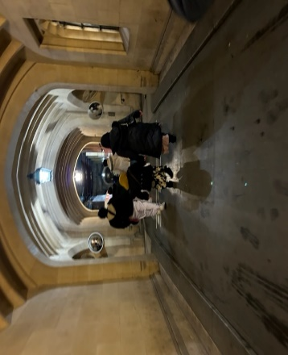 Paulette Hamilton MP, she answered questions that they have been wanting to ask and it was nice for her to show an interest as the young people felt very privileged.”

We then headed to West Minister Hall, Georgia stated “When we went down to Westminster Hall this was particularly emotional for me, since this was where people queued for hours waiting to see the Queen lying in state.”

At this point we were then allowed to take photos

Oh did we take hundreds of photos!

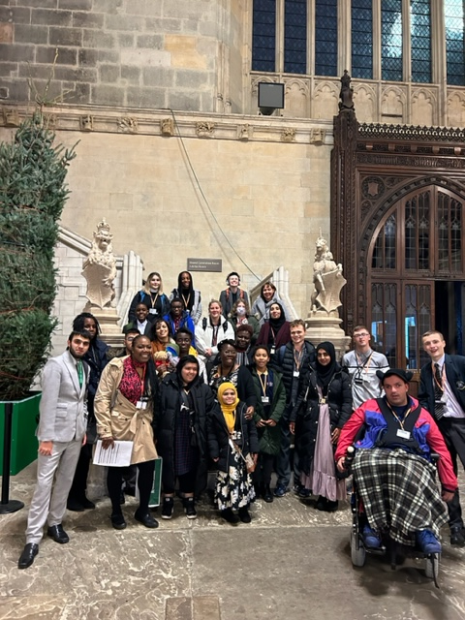MP Paulette Hamilton and her team then walked us round to our minibuses and waved us off as we headed back to Birmingham.

It took much longer than expected to get out of central London, we did not realise that celebrations for Albanian Independence Day were going to be taking place. This did not stop our joy, we chatted and listened to music until we arrive back to Birmingham to be collected by our parents.

Quotes from the Young People and parents,

***Hamza***

“I really enjoyed the trip; it was amazing thank you! It was one of the highlights of my whole life and thank you to everyone else who was included. Thank you everyone for making it an amazing experience.”

***Georgia***

“Singing Christmas songs and having a laugh with the group has boosted my confidence levels. I hope we continue to grow and make more changes to others #Respect.”

***Marium***

“I really enjoyed the trip to Parliament as it was a chance to see a lot of sightings and learn some interesting history behind many of the buildings.

I really enjoyed seeing the chambers and watching them live and it’s such a wholesome experience when you are there seeing it instead of watching it on the tv. I feel meeting with Mrs. Hamilton (MP) was also the highlight of the day as we could ask a lot of questions and speak our minds.”

***Mahreen***

“I extremely enjoyed my trip to parliament as I was able to experience a lot of things and meet quite few interesting people. I enjoyed everything on the day but particularly West Minister Hall where the late Queen was laying for three days after her passing, I found it interesting how you could see things on the tv and then actually be there in reality.”

***Miiya’s Father***

Thank you for allowing Miiya to take part in this day, she has had a brilliant day, something which she will remember for the rest of her life.”

***Kymarni’s Mother***

Thanks’ again for giving Kymarni this opportunity, it is so good that they’re experiencing these things. He has really enjoyed it and will sleep well tonight.”

***James Mother***

What a fantastic day James said he had, he loved it. Thank you

If you are 11-18 years of age and would like to join the RISE Forum,

Please contact [Keshia.hamilton@birmingham.gov.uk](mailto:Keshia.hamilton@birmingham.gov.uk)

If you are 18-30 years of age and would like to join YES!

Please contact [Sarah.kumar@birmingham.gov.uk](mailto:Sarah.kumar@birmingham.gov.uk)

