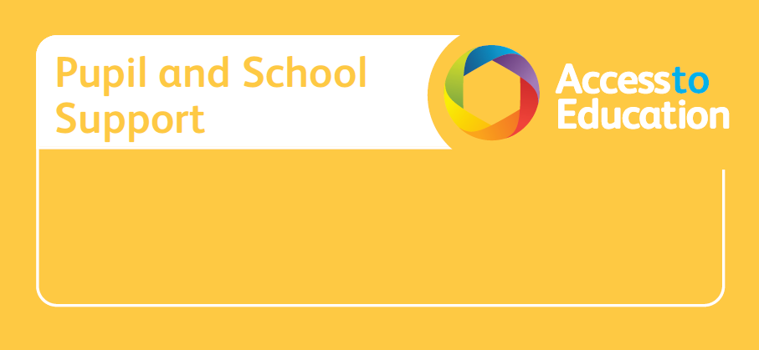

Person-Centred Review (PCR) Facilitator Training

‘The assessment and planning process should enable children and young people and their parents to express their views, wishes and feelings…… and be part of the decision-making process. This approach is often referred to as a person-centred approach…’ (SEN COP 2015)
Person-Centred Thinking Tools and Person-Centred Reviews (PCRs) help to involve young people and their parents in the decision-making process and increase engagement at all stages of the graduated approach.

Who is it for? This course is for, Education, Health and Social Care professionals who work with young people and their families. The course will give participants:

Day 1
- An introduction of the principles of Person-Centred practice.
- A range of practical person-centred tools to develop pupil voice and parental engagement in line with the Code of Practice. These tools can be shared with colleagues in school, to support throughout the graduated approach.

Day 2
- An understanding of the process and principles of Person-Centred Reviews (PCRs).
- Training in facilitation skills.
- Practical application of the PCR process and how to use information gathered to inform statutory requirements.

Wednesday 20th and Thursday 21st March 2024
Venue: Oakhill Centre, Oakhill Close, Birmingham, B17 8BB

Cost for 2-day training: £395
Reduced to £300 per participant, if 2 or more participants per setting)

Refreshments included. Please bring your own lunch.

Visit accesstoeducation.birmingham.gov.uk to book a place on the course or email pssinfo@birmingham.gov.uk for more information

