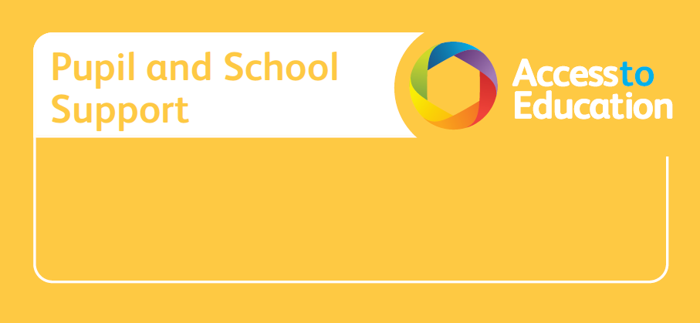

Interpretation of Toolkit Progress Tracker Data to support Provision Management

The Toolkit Progress Tracker is an online tool built around the Birmingham SEN Language and Literacy and Mathematics Toolkits that enable schools to:
- track and analyse individual, group and whole school toolkit data to demonstrate and report progress for those pupils working below their year group expectations
- systematically access teaching and learning activities to support planning provision
- produce documents at the click of a button to report to SMT, Governors, Ofsted
This course supports schools to
- interpret Toolkit Progress Tracker data to inform their development and adaptation of the curriculum
- evaluate whether pupils’ outcomes are improving as a result of the different or additional provision being made for them.
- monitor and quality assure the data and its use for provision and learning


Please note: This course is only suitable for schools who have purchased and attended training in the use of the Toolkit Progress Tracker.

Outcomes:
Course attendees will develop an understanding of how to interpret their Toolkit Progress Tracker data to support a strategic provision management process which focuses on:
- Analysis of assessment data
- Evaluating interventions
- Developing the quality of provision
- Developing the workforce
- Identifying the right provision for all children
- Knowing the vulnerabilities of all children

Tuesday 20th February 2024
9:00am – 12.30pm Cost: £120.00
Oakhill Centre, Oakhill Close, Harborne, Birmingham. B17 8BB

To secure your place on this course please book online via:
http://accesstoeducation.birmingham.gov.uk

