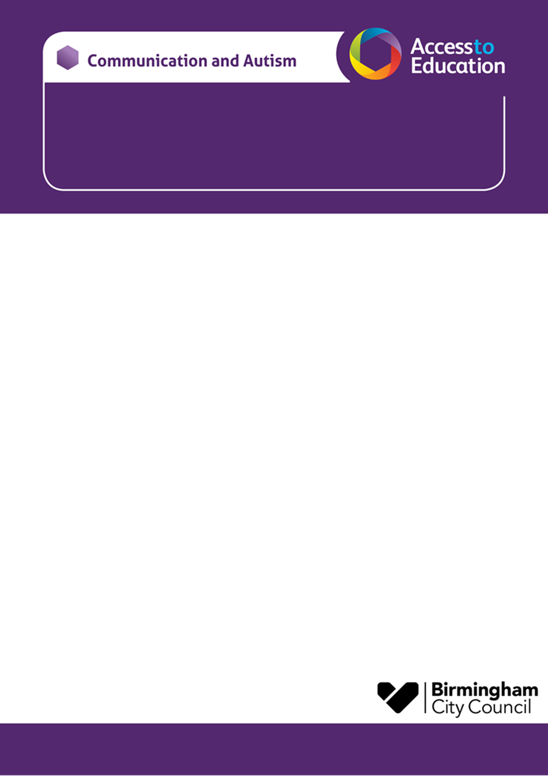

**18th and 26th June 2024**

**A Workshop for Parent Carers of Year 6 Children**

**Moving from Primary to Secondary School**

**This CAT transition to secondary school workshop will help you:**

* ***Consider how to support your child’s independence skills as they move from primary to secondary.***
* ***Consider how to prepare your child for this time of change in their lives.***
* ***Think about how you can work alongside your child and their schools to support a smooth transition.***
* ***Consider ways to support your child to build confidence, resilience and independence for the changes ahead.***
* **We are offering two workshops, to enable parent carers to access a workshop in the daytime or evening**

*(you only need to book on / attend one of the workshops)*

* **The workshop will be delivered virtually via Microsoft TEAMs. A link will be sent to you before the session.**
* **Each session will last for 90 minutes.**

|  |  |
| --- | --- |
| Daytime Workshop | Tuesday 18th June 2024  1.00 - 2.30pm |
| Evening Workshop | Wednesday 26th June 2024  6.00 - 7.30pm |

**To secure a place for the workshop please email: *A2EGeneral@birmingham.gov.uk* to reserve a place.**

**The subject or title of your email needs to state that it is for the -Transition Parent Carer Workshop Summer 24**

***In your email please include:***

* **Your name and email address**
* **Your Child / young person’s name and school**
* **Your child / young person’s CAT worker *(if known)***
* **The workshop you wish to attend -**
* **Tuesday 18th June 1pm or Wednesday 26th June 6pm**
* **Due to limited places, the course will be offered to the first families to contact us.**
* **You will receive an email response to confirm your place, or to tell you that the course is full. Cath Mohan and Jo Clifford**

.