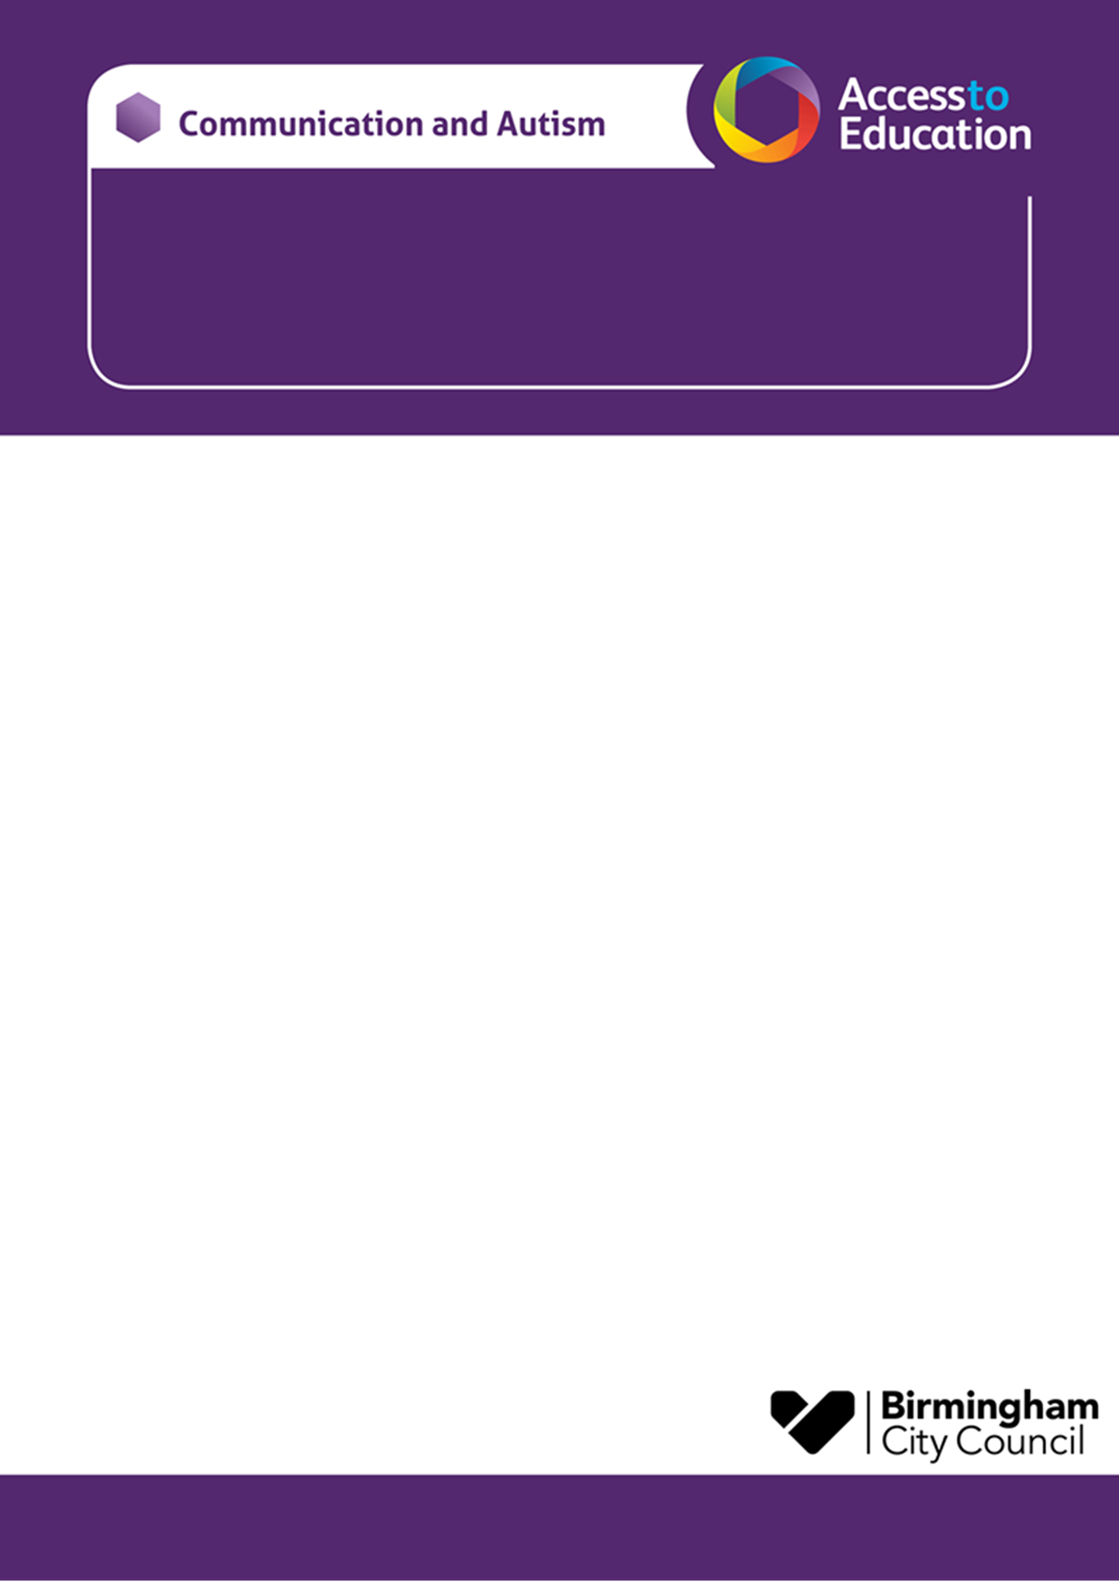

**Autumn Term 2024 CAT PAC – Primary School Age**

**SOUTH Rednal Hill Juniors school – B45 8QY**

**We would like to invite you to a CAT PAC course, our parent awareness course designed to support parent carers of children with a diagnosis of autism or children who are on the neurodevelopmental pathway for assessment.**

* The course has been designed for parents who want to increase their understanding of autism.
* The sessions will take place at Rednal Hill Junior School

**AUTUMN TERM 2024**

|  |  |
| --- | --- |
| Session1 – An introduction to Autism | Tuesday 8th October 9.30-11.30am |
| Session 2 – Communication and Interaction | Tuesday 15th October 9.30-11.30am |
| Session 3 – Sensory differences | Tuesday 22nd October 9.30-11.30am |
| **HALF TERM** |  |
| Session 4 – Eating, sleeping, personal care | Tuesday 5th November 9.30-11.30am |
| Session 5 – Autism and Anxiety | Tuesday 12th November 9.30-11.30am |
| Session 6 – Parent/ carer choice & signposting services | Tuesday 19th November 9.30-11.30am |

**The subject or title of your email needs to state that it is for the :**

**Autumn 2024 Primary CAT PAC – Rednal Hill Junior School**

***In your email please include:***

* Your name – Parent carer
* Your Child’s name
* Your Child’s school ( Add your child’s CAT worker if known)
* Due to limited places, the course will be offered to the first families to contact us.
* *There is an expectation that parents try to attend all sessions if possible.*
* Please email***A2EGeneral@birmingham.gov.uk*** to reserve a place.

*You will receive an email response to confirm your place or to tell you that the course is full.*

**Yours sincerely,**

**Katie Price, Lisa Walmsley and Wendy Bantock.**